Croydon Hills Primary Vacation Care Program
Campaspe Drive, Croydon Hills, 3136 9724 4514
ray.mandy.m@edumail.vic.gov.au

Monday 15th January – Thursday 25th January, 2018.
7:30am - 6:00pm

Child Care Benefit
All families are encouraged to apply for reduced fee. If you are not already registered for the Child Care Benefit, contact the Family Assistance Office on 13 61 50. Once you have provided the FAO with your details, they will calculate your childcare benefit percentage and will then issue you with a Child Care Benefit Assessment Notice. You will be required to provide our programs Service Provider Number.
Croydon Hills Vacation Care Provider Number ~ 1-631-4932

Dates and times
The program will operate from 7:30am until 6:00pm, beginning on:

Monday 15th January – Thursday 25th January 2018.

A late fee of $1 per minute applies to each child after 6pm.

Booking Procedures
- No telephone bookings will be accepted.
- Completed booking forms are to be left at the Croydon Hills Primary School Office or the After School Care room. Each application will be processed in order of receipt. The coordinator will contact you and advise of places available and total amount owing.
- Bookings will be made according to the priority of access regulation. Refer to policy for further information regarding this procedure.

~PLEASE NOTE: The mobile number provided on the back door at the service should ONLY be used during excursion hours.~

Cancellations and Alterations
Once the Vacation Care enrolment form has been handed in, a $5 alteration fee applies for any changes to your bookings up until the last day of the school term, Friday 22nd December 2017.

Please Note: As of 6pm Friday 22nd December 2017, NO refunds will be given.
$5 Emergency Booking Fee
A $5 per child emergency booking fee will be charged to all bookings that are made once the holiday program has commenced. Payments for additional bookings must be made prior to or on the day of care required.

Payments
All bookings must be paid by Tuesday, 19th December, 2017. If payment is not made by this date, all bookings will be cancelled. Payments by credit card, cheque, EFTPOS and cash are accepted and can be made at the Outside School Hours Care Office.

Snacks, Lunches and Drinks
Parents are to supply nutritious lunches as well as drinks and snacks for their children. Please note that we cannot heat or cook children’s snacks or lunches.

*PLEASE NOTE* - PEANUT BUTTER AND NUT PRODUCTS ARE NOT TO BE BROUGHT INTO THIS SERVICE DUE TO SEVERAL CHILDREN ATTENDING THE SERVICE WHO ARE AT RISK OF ANAPHYLAXIS WHEN THEY COME INTO CONTACT WITH THESE FOOD PRODUCTS.

General Program Guidelines
Children must be signed in and out of the program by parent/legal guardian or authorised person over the age of 18 years of age. All children must be signed in and out of the program each day; no child is to leave the program unattended. Parents must provide a copy of any court order which relates to custody arrangements for children in care during the program. If the child has additional needs, parents are asked to provide clear and informative details so that staff can provide the best possible care for the child.

Medication
If a child is to receive medication during the day, parents must complete the medication instruction sheet. Medication must be in the original containers with the original labels and the child’s name and specific dosage clearly visible on the medication. If over the counter medication is required, staff must administer as per instructions on the package. If any deviation from instructions is required, a medical certificate will be required detailing dosage.

PLEASE NOTE THAT THE PROGRAM PROVIDES NO MEDICATION OF ANY KIND.

Excursions
On excursion days children must be at the centre at least 20mins before the stated departure time. This will help us to avoid being late. We do not wait for late arrivals.

Clothing
Parents must ensure that their children have appropriate clothing and footwear for the weather.
All children must wear a broad brim hat outside and on excursions during the January holiday program.

1st of May ~ Hats Away
1st September ~ Hats to Remember

For further information please contact Mandy or Debby on 9724 4514
Please leave a message and we will get back to you.

Mandy Ray

VAC Coordinator

9724 4514

Bookings
The base rate for Vacation Care Program is $48 per day, plus the cost of the excursion/incursion. This is the cost before the Childcare Benefit and Childcare Rebate are deducted.

Using the table below please indicate your child/ren’s attendance during the holiday period by placing an ‘X” in the box corresponding to the days you require.

Days | Cost | Child A | Child B |  | Child C | Child D
Monday, 15th January | $68
Tuesday, 16th January | $64
Wednesday, 17th January | $75
Thursday, 18th January | $66
Friday, 19th January | $75
Monday, 22nd January | $68
Tuesday, 23rd January | $61
Wednesday, 24th January | $48
Thursday, 25th January | $68
Friday, 26th January | Australia Day – Public Holiday

Please Tick this box if you give authorisation to deduct fees using your
credit card details held at OSHC

- Please note we DO NOT KEEP credit card details on file unless a parent has given us authorisation to do so.

Croydon Hills Vacation Care Program
Campaspe Drive, Croydon Hills. Our hours are strictly 7:30am – 6:00pm

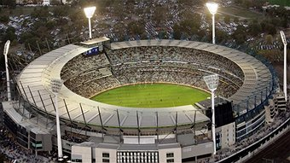
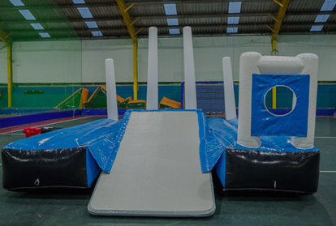
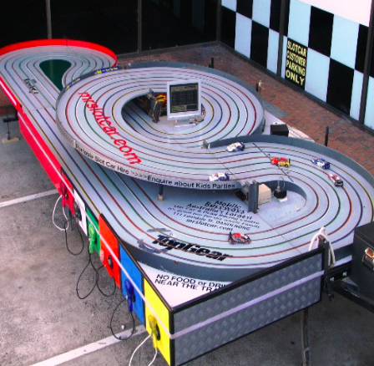
Phone: 97244514 Email: ray.mandy.m@edumail.vic.gov.au
Monday 15th Jan | Tuesday 16th Jan | Wednesday 17th Jan | Thursday 18th Jan | Friday 19th Jan
Incursion: Bubble Sports  8:30am – 1:30 pm  Bubble Sports  Back by popular demand  Variety of inflatable AFL activities to bounce you way through the day. | Incursion: Slot Cars  10am – 2pm  Mr. Slot Cars  Is coming to visit today. A portable slot car racetrack, race against your mates. Lots of fun to be had | Excursion: Latitude  Leave: 9:45 am  Return: 1 pm  Latitude  Heidelberg, Melbourne  Come and bounce, fly and climb your way through the session.  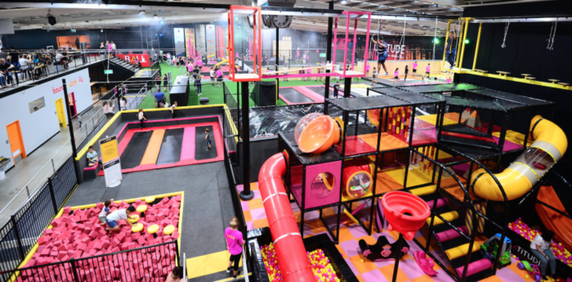  Closed two shoes and socks MUST be worn! | Incursion: Splashtastic Fun  Group 1: 10 am – 11am  Group 2: 11am – 12 pm  Action packed session of water games, splash ball dodge ball, water cup relay, water shooter run and lots more.  BYO: bathers, towel and a change of clothes. Thongs/old shoes must be worn during this activity. | Excursion: MCG Tour & National Sports Museum  Leave: 9:30 am (SHARP)  Return: Approx 2 pm  Today we are touring the  MCG and National Sports Museum.  Tour operates 11am-1pm
Monday 22nd Jan | Tuesday 23rd Jan | Wednesday 24th Jan | Thursday 25th Jan | Friday 26th Jan
Incursion: Water Works  Group 1: 10am – 11am  Group 2: 11:30am – 12:30pm  Water Works  Join in water pistol practice, bobbing for Ping-Pong balls, water balloon throwing contest and lots more.  BYO: bathers, towel and a change of clothes. Thongs/old shoes must be worn during this activity. | Incursion: Wax Hands  10am onwards  Wax Hands  Dip your hand straight in and watch the magic of the wax transform into a great keepsake to take home.  Craft activities in the afternoon. | Australia Day Craft and Games  Including:  Koala in a pond for morning tea (jelly cups) and icy poles in the afternoon.  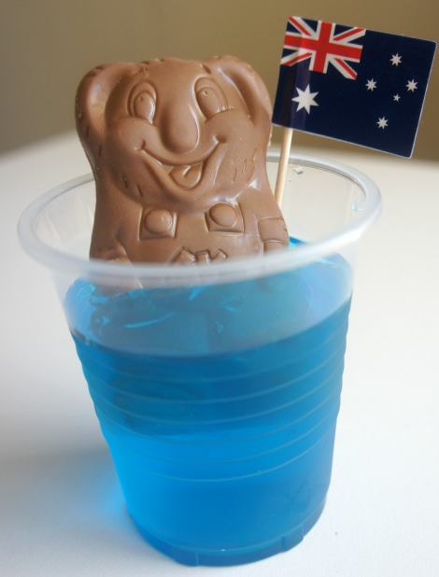 | Excursion: Reading Cinemas  Must be at school by 9am  (am session)  Movies:  Coco (PG)  Reading Cinemas, Chirnside Park | AUSTRALIA DAY  PUBLIC HOLIDAY  NO PROGRAM  .

Croydon Hills Vacation Care Program - 9724 4514
January 15th – January 25th , 2018 7:30am – 6:00pm

Excursion on Wednesday 17th January:

Venue: Latitude, 590 Waterdale Road Heidelberg West 1300 123 528
Leave: 9:45am Return: 1 pm
Staff / Ratio: Minimum of 1 staff member for every 8 children
Contact details: Mandy – 0432 581 324

Excursion on Friday 19th January

Venue: MCG Tour and National Sport Museum, Brunton Ave Richmond 9657 8888
Leave: 9:30 am Return: 2 pm
Staff / Ratio: Minimum of 1 staff member for every 8 children
Contact details: Mandy – 0432 581 324

Excursion on Thursday 25th January:
Venue: Reading Cinemas, Maroondah Hwy, Chirnside Park 9727 7900
Leave: (am session) To be advised closer to the date Return: To be advised closer to the date
Staff / Ratio: Minimum of 1 staff member for every 8 children
Contact details: Mandy – 0432 581 324

We are taking the children on excursions to:
- Have fun
- Develop gross motor skills
- Be aware of stranger danger when on an outing
- Participate in group activities in specialized events
- Develop problem solving skills
- Participate in group social interactions
- Understand and learn how to behave in a public place in the group situation

Croydon Hills Vacation Care Program
January 15th – January 25th, 2018
I give permission for my child/ren to attend the following excursion/s as outlined above.

Wednesday 17th January  Latitude, Melbourne  Children  1.  2.  3.  Parent/Guardian:  Signature:  Emergency contact names and numbers for this day:  1:  2: | Friday 19th January  MCG Tour, Richmond  Children  1.  2.  3.  Parent/Guardian:  Signature:  Emergency contact names and numbers for this day:  1:  2: | Thursday 25th January  Reading Cinemas,  Chirnside Park  Children  1.  2.  3.  Parent/Guardian:  Signature:  Emergency contact names and numbers for this day:  1:  2:

Please inform staff if your child has any allergies / medical conditions that staff should be aware of specific to these excursions.

